**Assignment-7**

# Uploading a Static Website on an Amazon EC2 Server

**Overview**

Steps:

1. Creating an EC2 instance
2. Connecting to the server using Bitvise SSH Client
3. Installing and configuring the NGINX web server
4. Uploading and hosting a static website on EC2
5. **Remark**: This method allows you to run a static website on a cloud-based server without needing external hosting services.

# Step 1: Create an EC2 Instance

1. 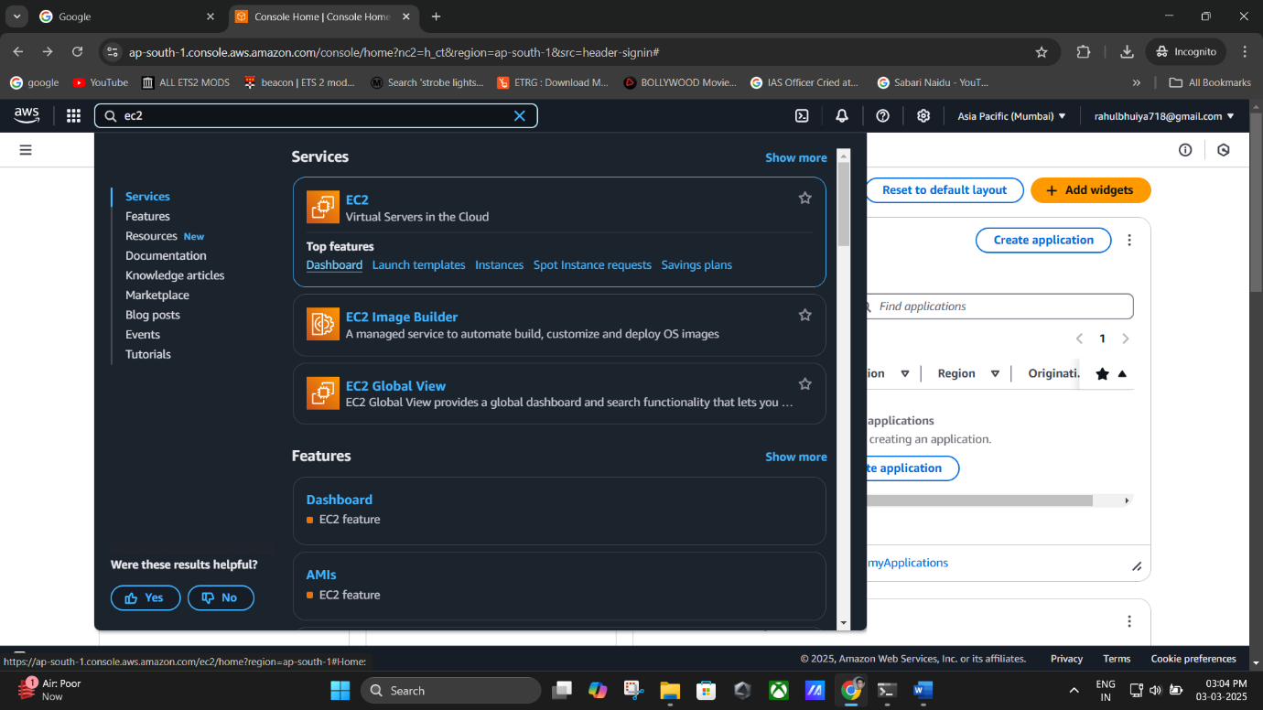Sign in to the **AWS Management Console** and open the **EC2 console**.
2. 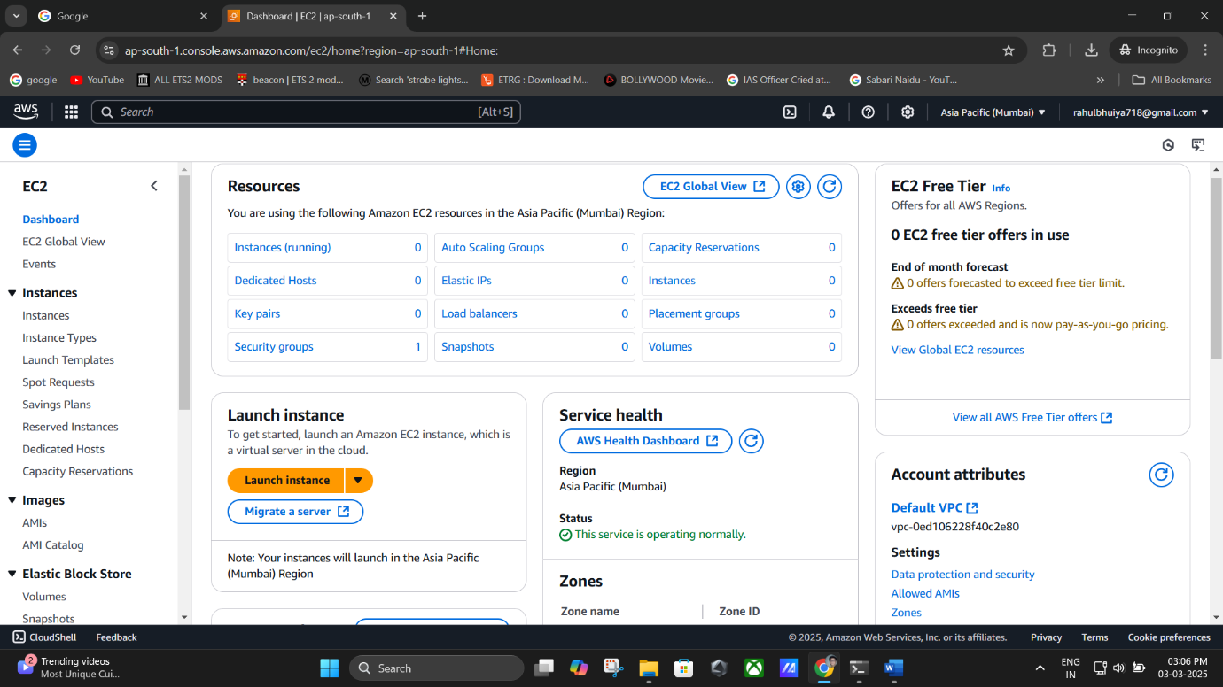Click **Instances (Running)** → **Launch Instance**.
3. In the **Launch an Instance** page:
   * Under **Name and Tags**, enter a descriptive name (e.g., rahulwebserver).
   * Under **Application and OS Images (Amazon Machine Image)**:
     + Choose **Ubuntu** from the **Quick Start** options (Free Tier Eligible).
   * 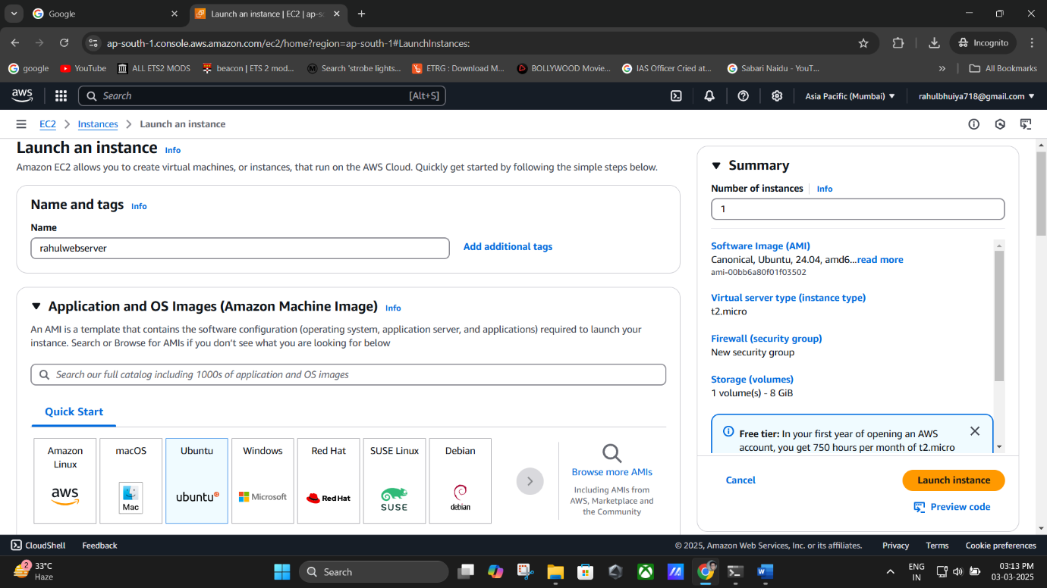 Under **Instance Type**, select **t2.micro** (Free Tier Eligible).

**(Names & Tages and Ubuntu Selected).**

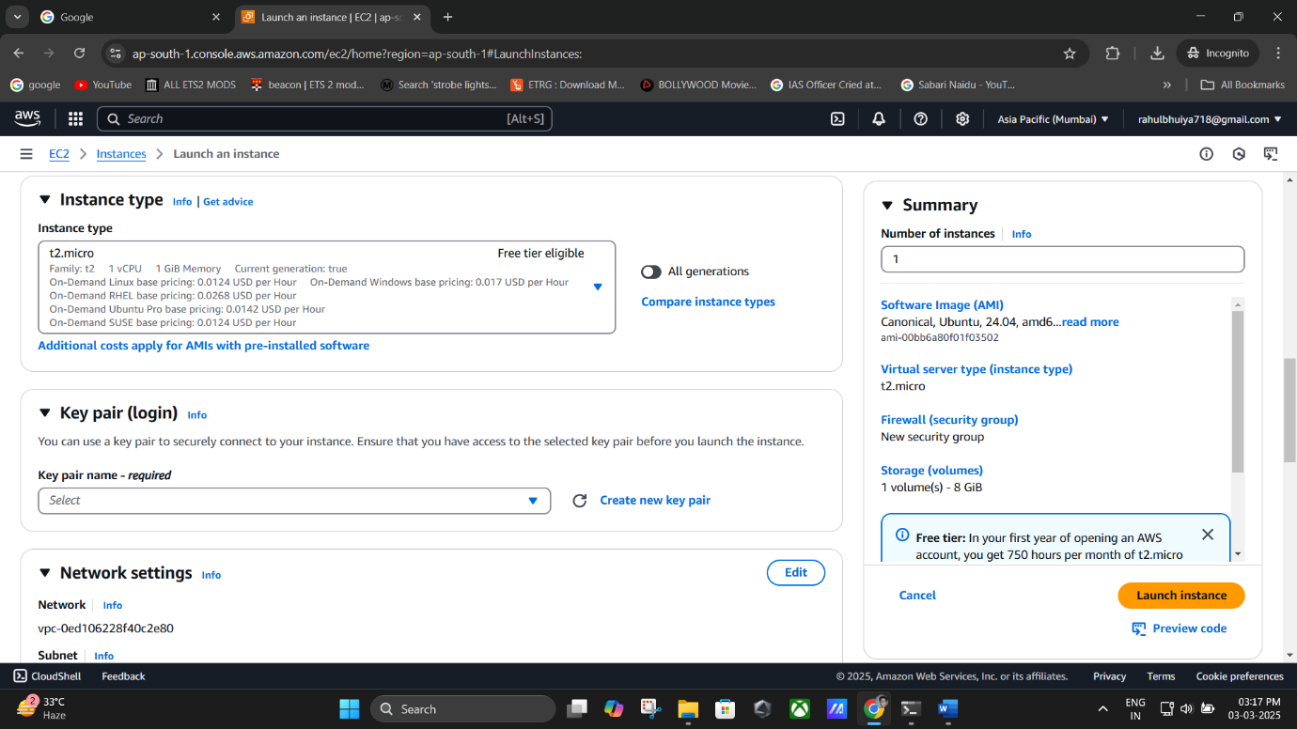

**(selecting t2.micro (Free Tier Eligible)).**

1. **Configure Key Pair (Login)**:
   * Select an existing key pair or create a new one.
   * If creating a new key pair:
     + Enter a **Key Pair Name** (e.g., rahul1234).
     + Select **RSA** key type and **.pem** format.
     + 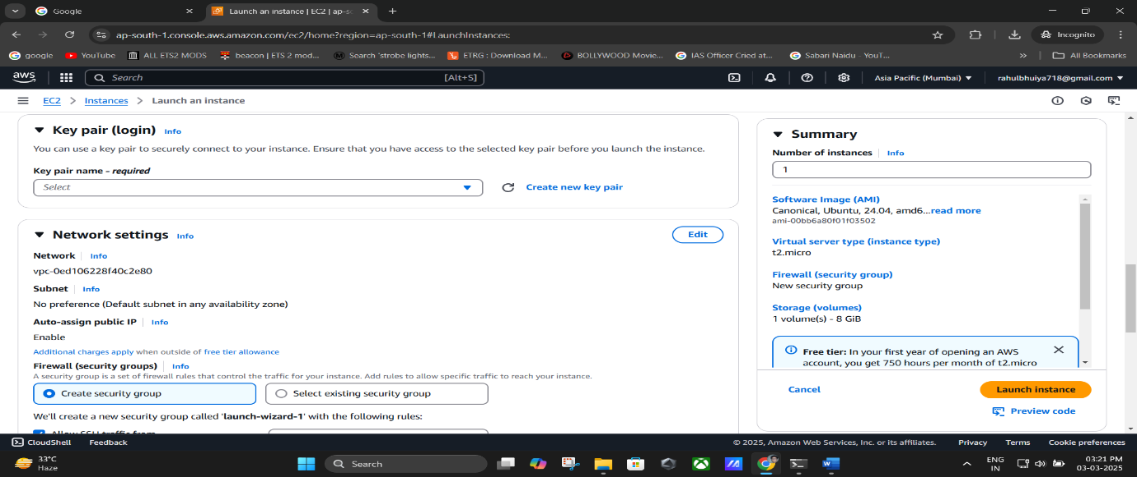Click **Create Key Pair**, and the .pem file will be downloaded automatically. **Save this file securely.**

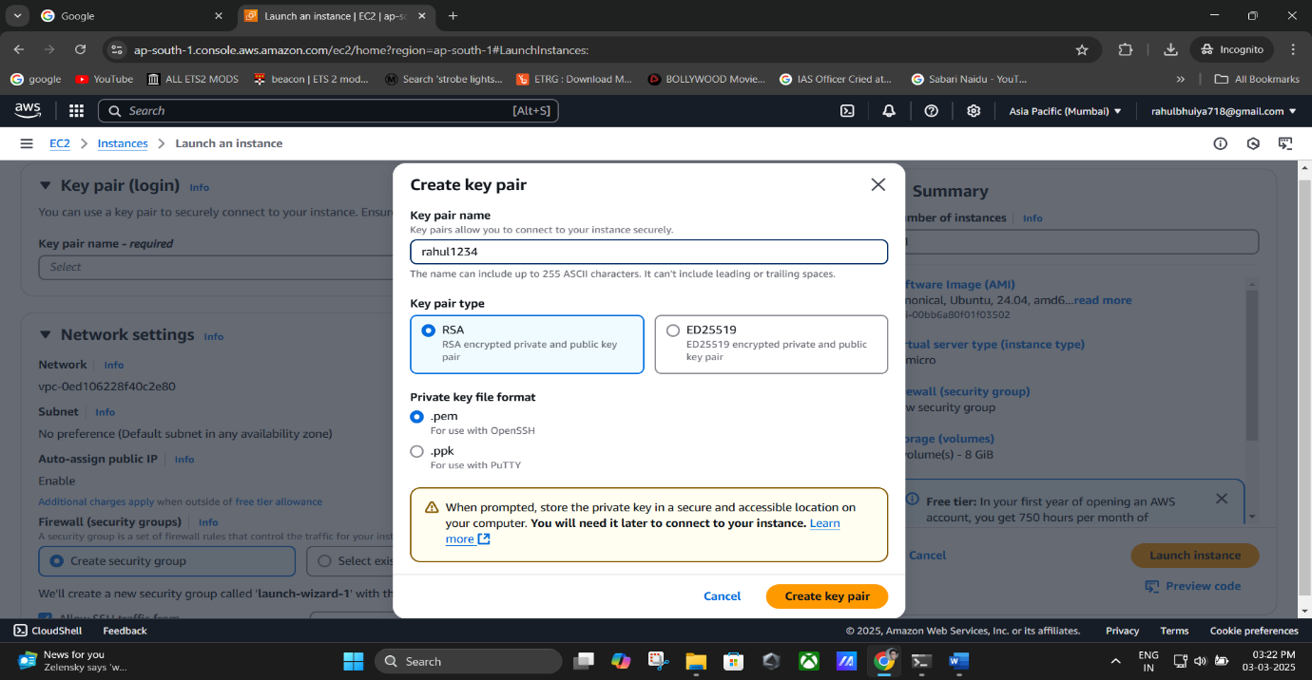

**(Entering Key Pair Name -> RSA Key and .pem formate -> Click Key Pair).**

1. **Configure Security Settings**:
   * Under **Firewall (Security Groups)**, check the following:

✅ **Allow SSH traffic** (To connect to the instance)

✅ **Allow HTTPS traffic** (For secure browsing)

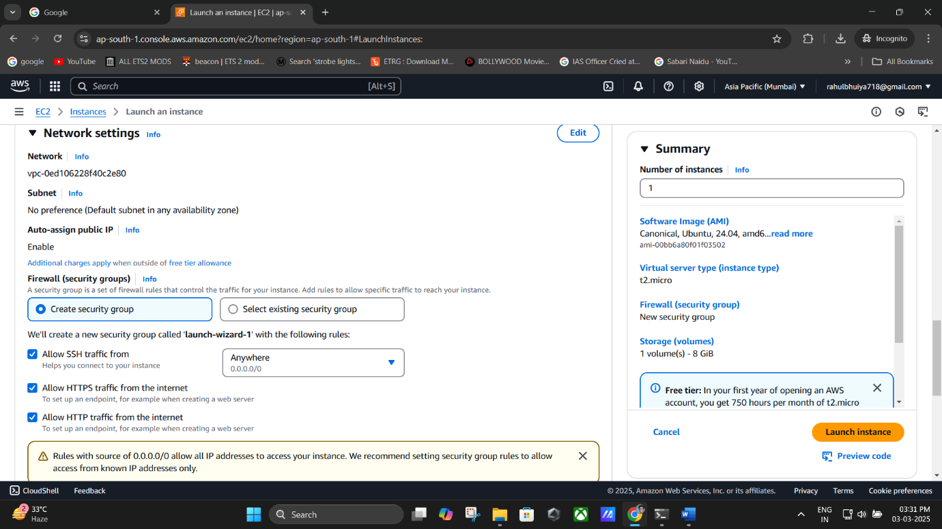✅ **Allow HTTP traffic** (To host the website)

1. Review the instance configuration and click **Launch Instance**.

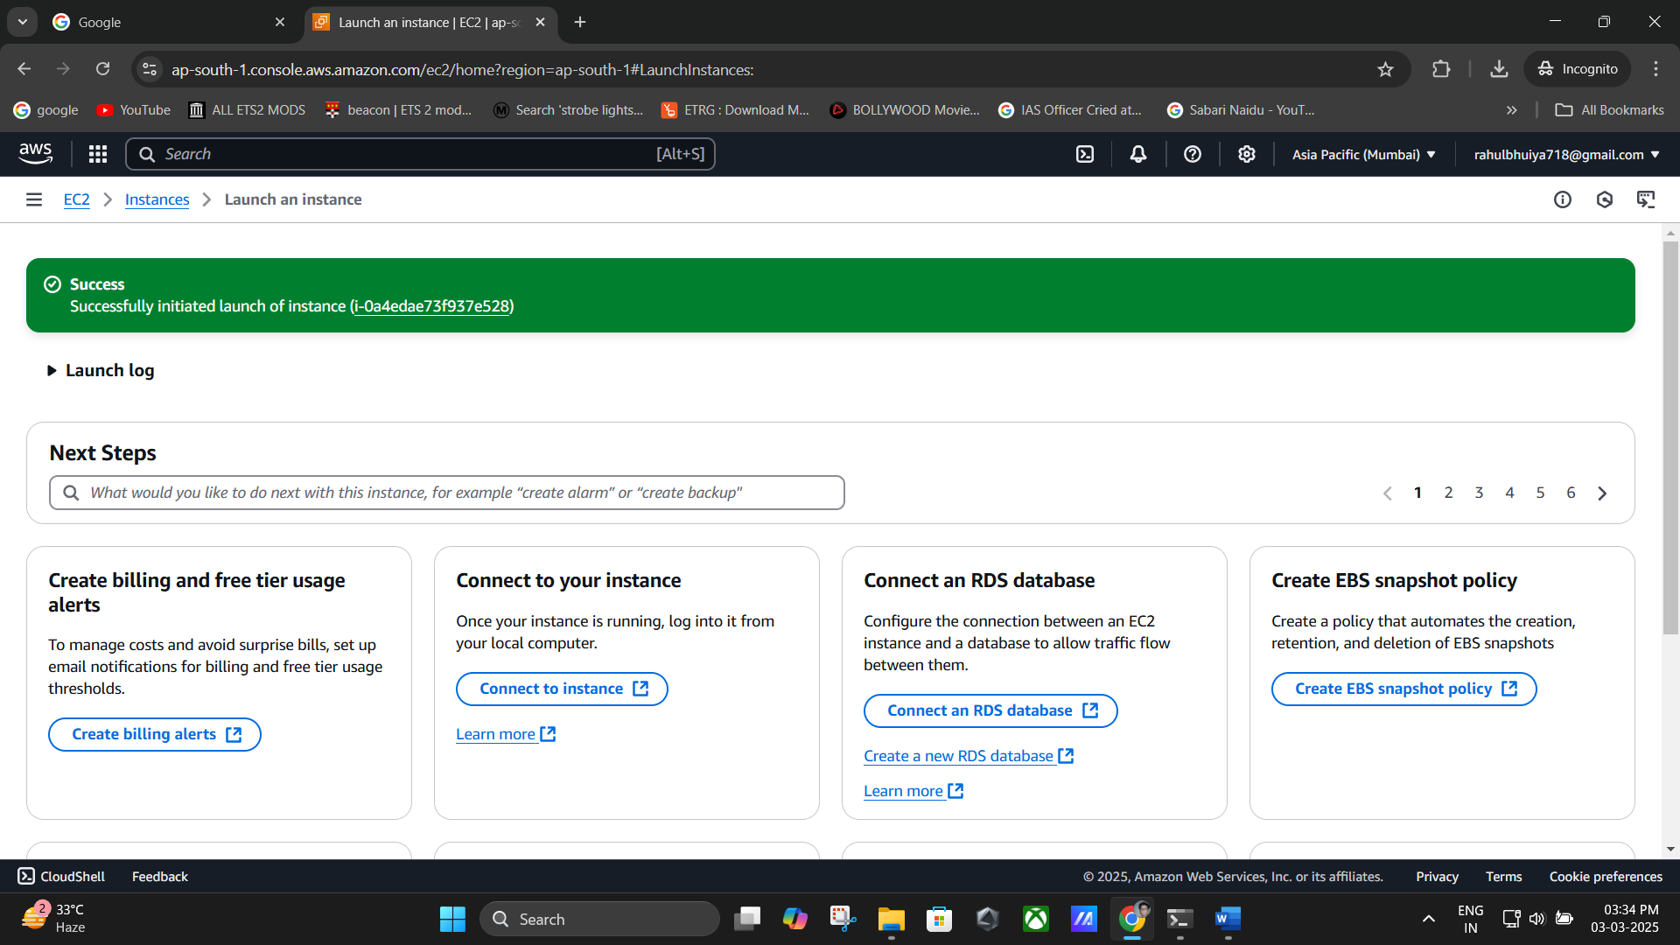

1. 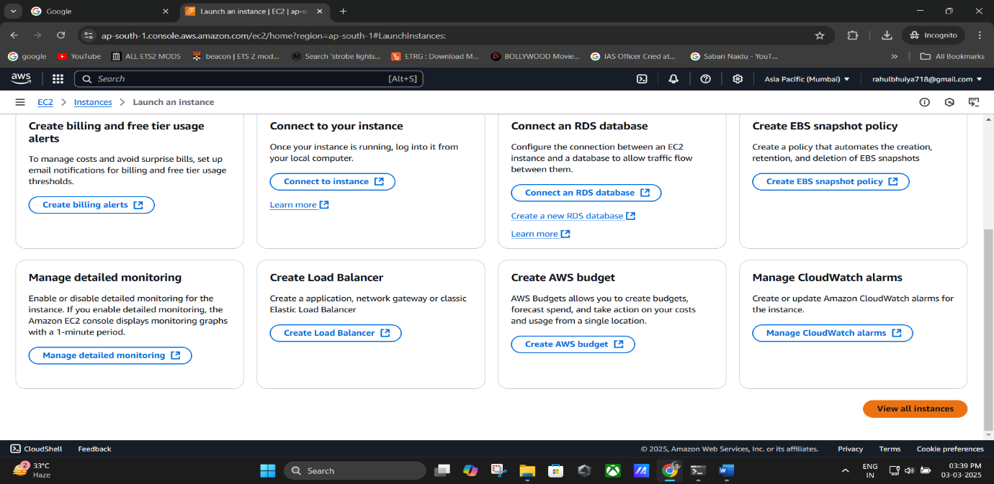After a few minutes, go to **View All Instances** to see the running instance

**(Clicking “View all instruction”).**

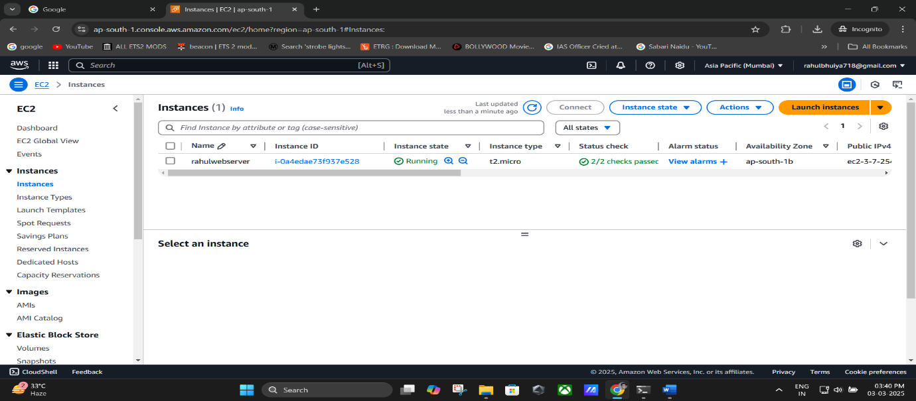

**Remark**: Ensure you have the **.pem key file** downloaded; it is required for SSH access.

# Step 2: Connect to EC2 Instance Using Bitvise SSH Client

1. 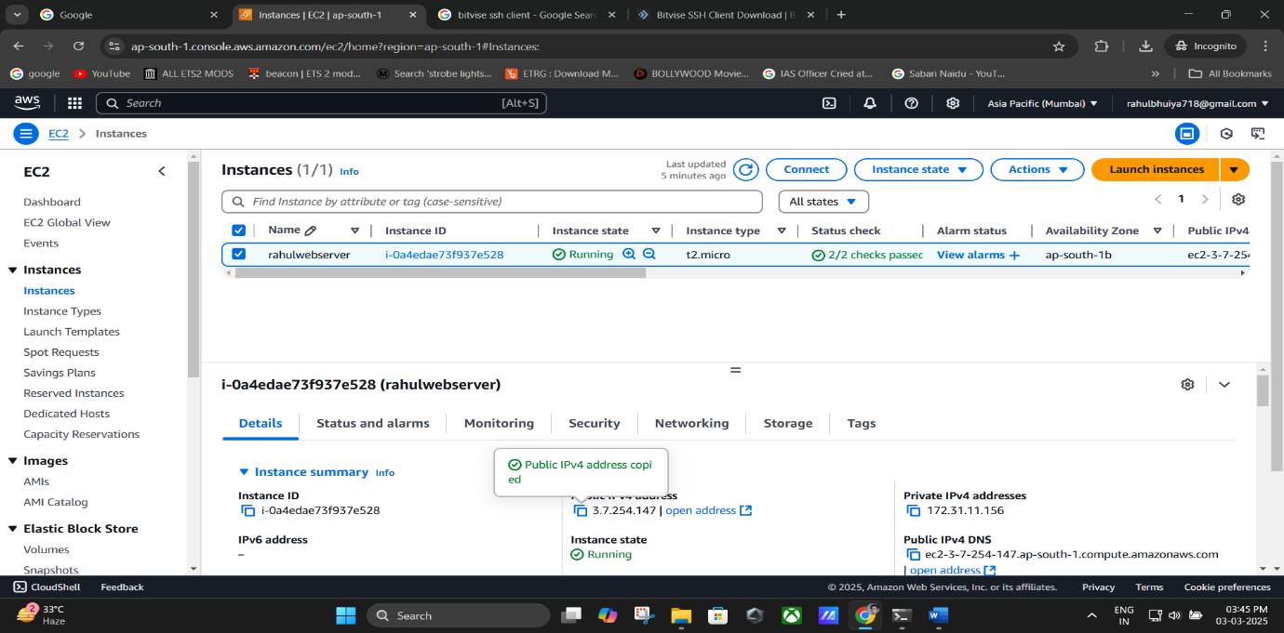Select your running instance and copy the **Public IPv4 Address**.

**(Copy Public IPv4 Address).**

1. Download and install **Bitvise SSH Client** from your browser.

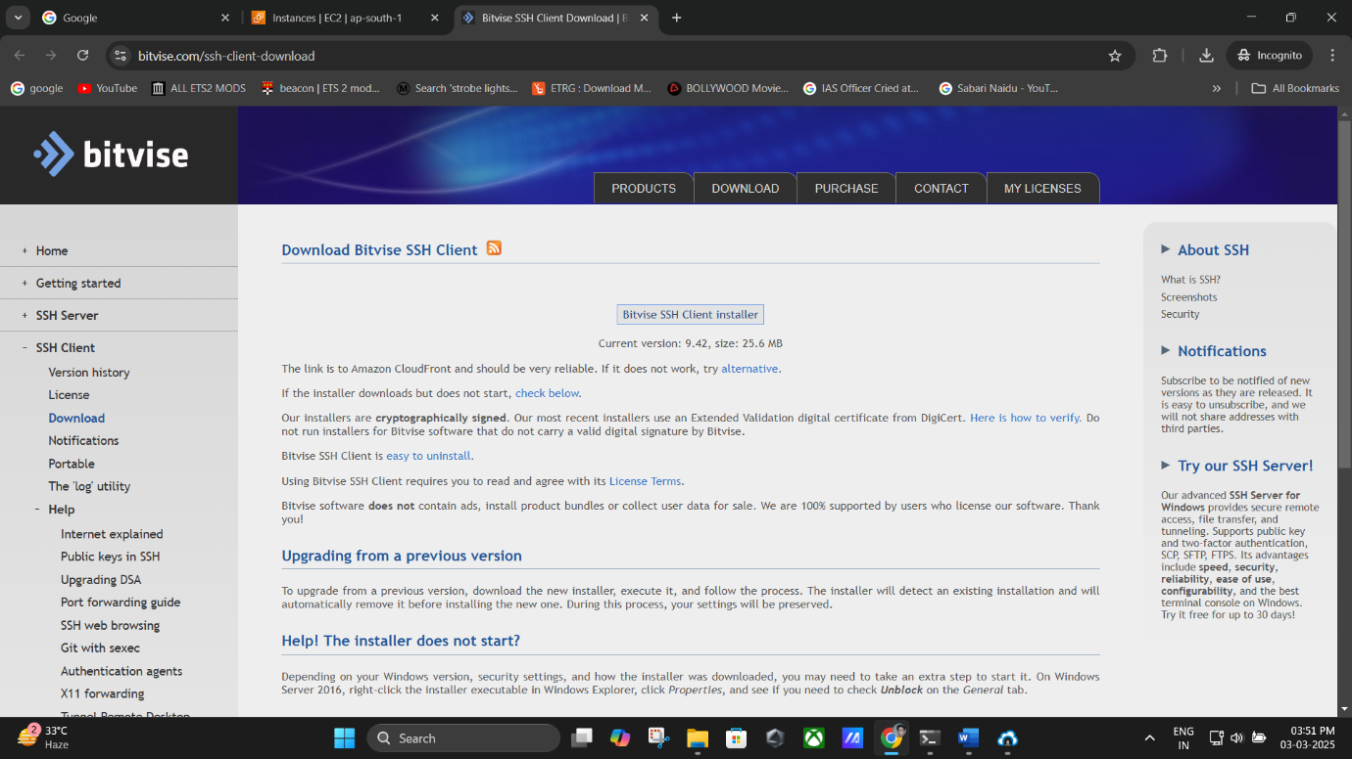

1. Open **Bitvise SSH Client** and enter:
   * **Host**: Paste the **Public IPv4 Address**.
   * **Username**: ubuntu
   * 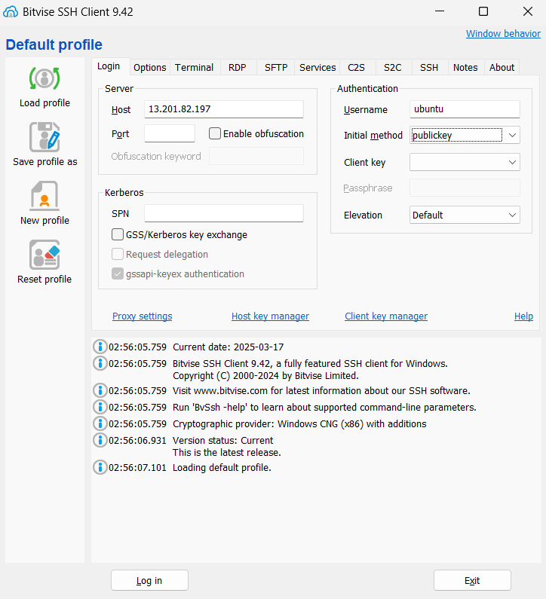**Initial Authentication Method**: Select **public key**.
2. Click on **Client Key Manager** → **Import**.
   1. Choose the **.pem key file** downloaded earlier.
   2. Click **Open → Import**.
   3. The key appears as **Global 1**.

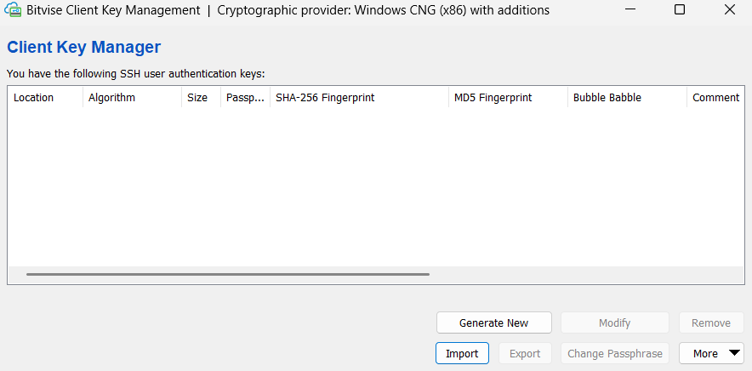

**(Client Key Manager).**

**(Click On Import).**

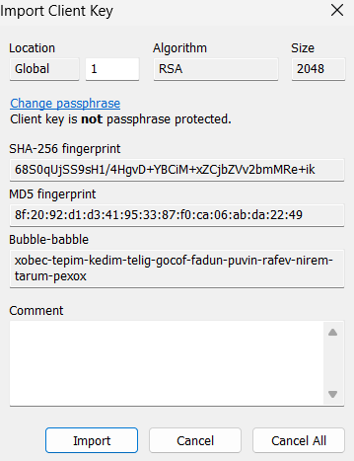

**(Click On Import)**

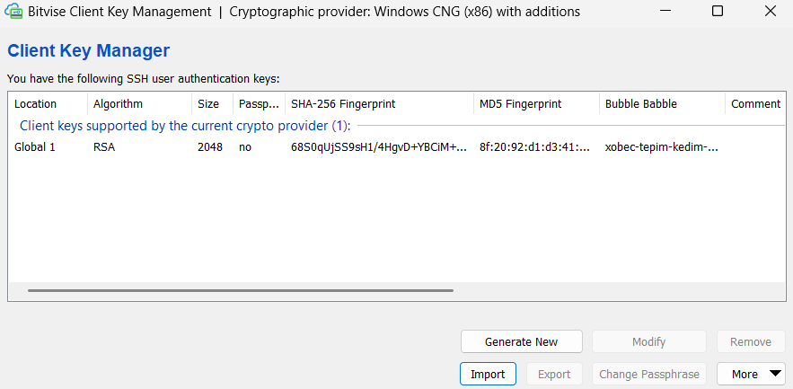

**(The key appears as Global 1).**

1. Click **Login** → **Accept & Save**.

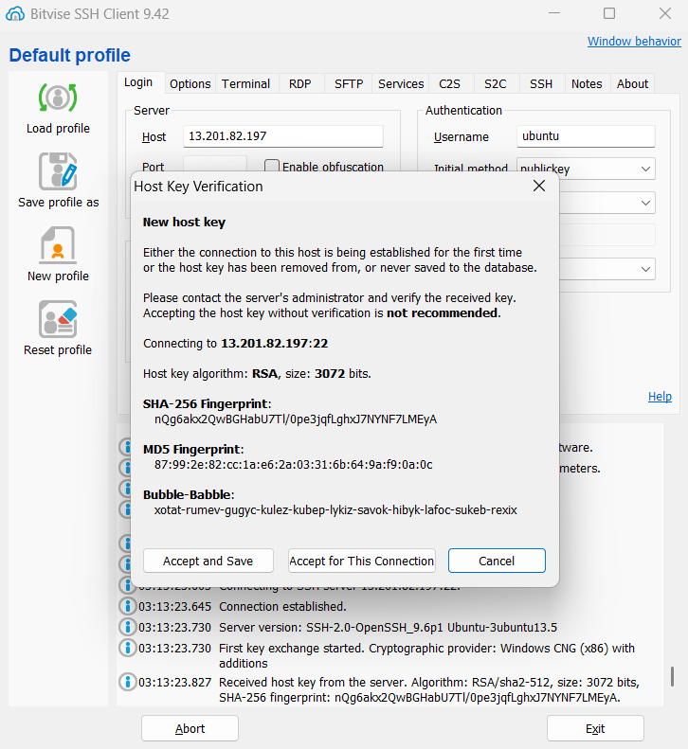

(**Click Login**→ **Accept & Save**).

1. Open a **New Terminal Console** in Bitvise and run the following command to update packages:

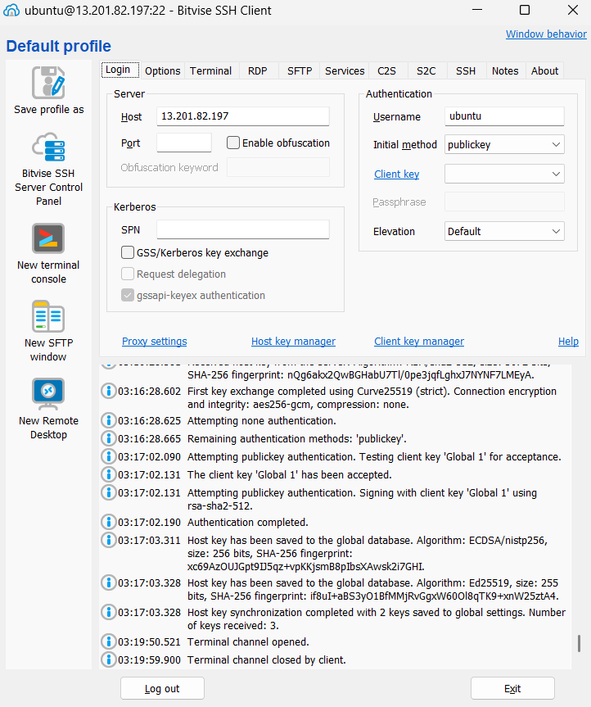

**(Click on New Terminal Console).**

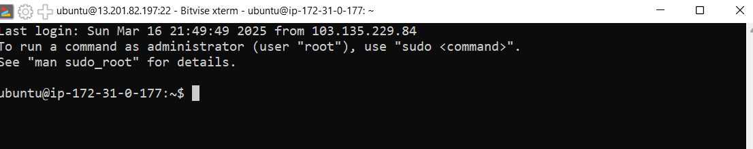

(**Here New Terminal Consol is opened**).

1. sudo apt-get update && sudo apt-get upgrade
   1. When prompted, type y and press **Enter**.

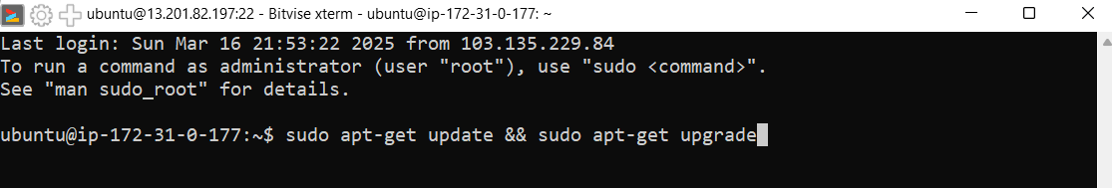

**(Pasting the code “sudo apt-get update && sudo apt-get upgrade”).**

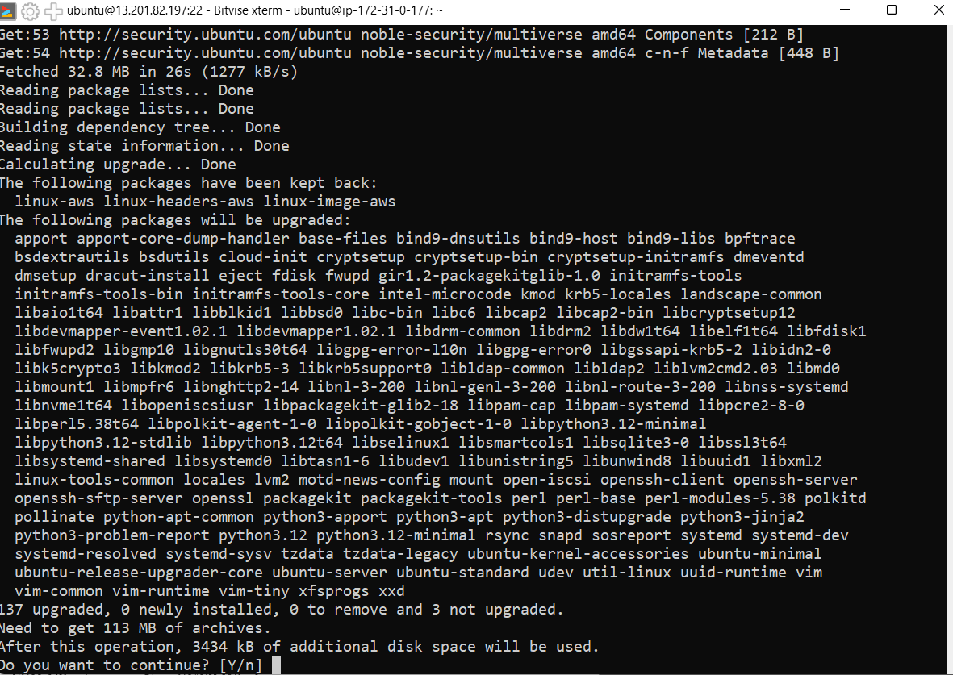

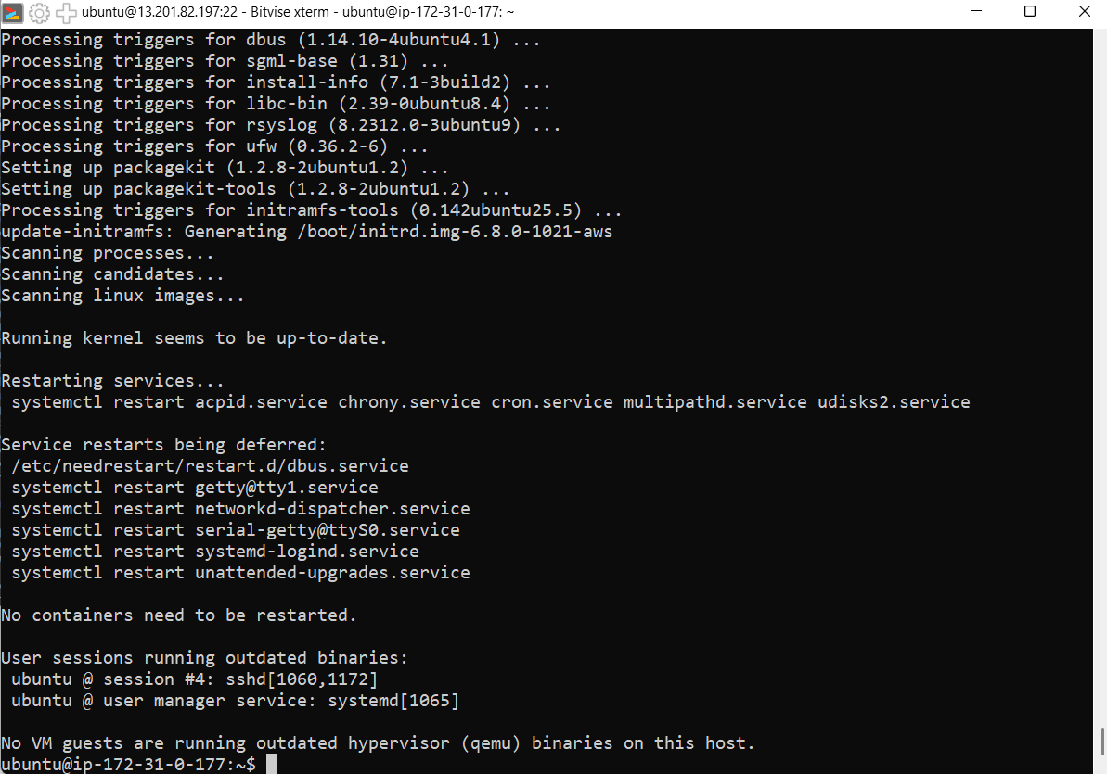

**(type y and press Enter).**

# Step 3: Install and Configure NGINX Web Server

1. In the **New Terminal Console**, install NGINX:

sudo apt-get install nginx

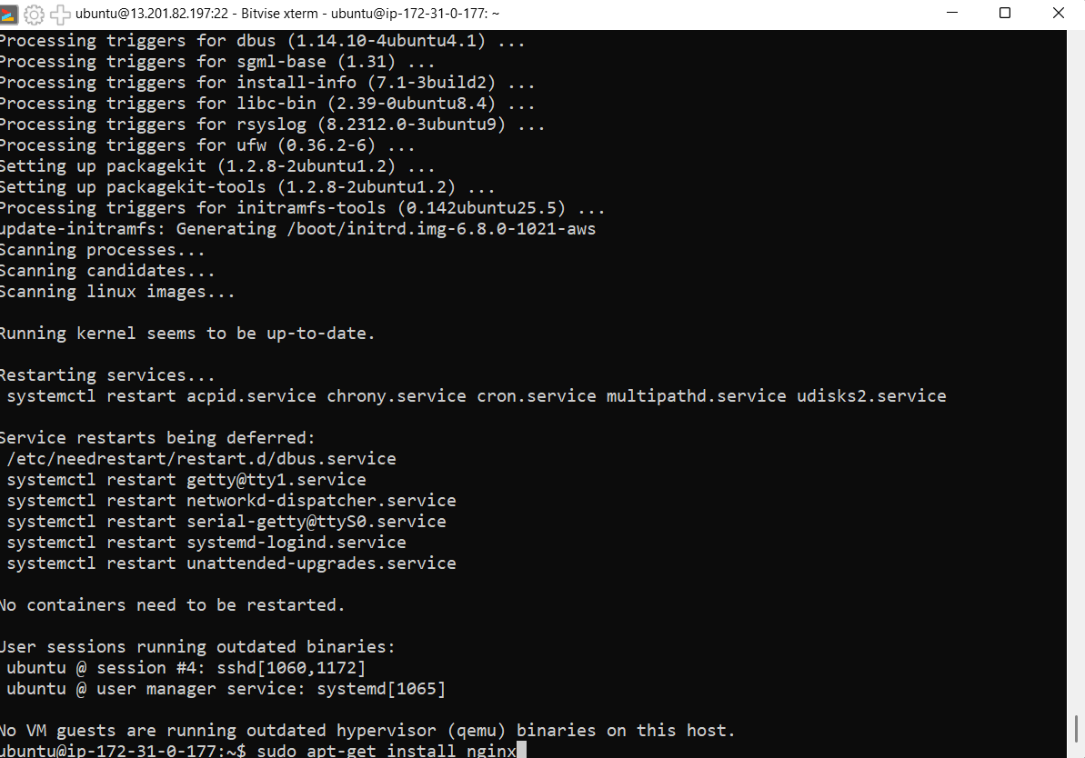When prompted, type y and press **Enter**.

**(Paste the code “sudo apt-get install nginx” in the terminal).**

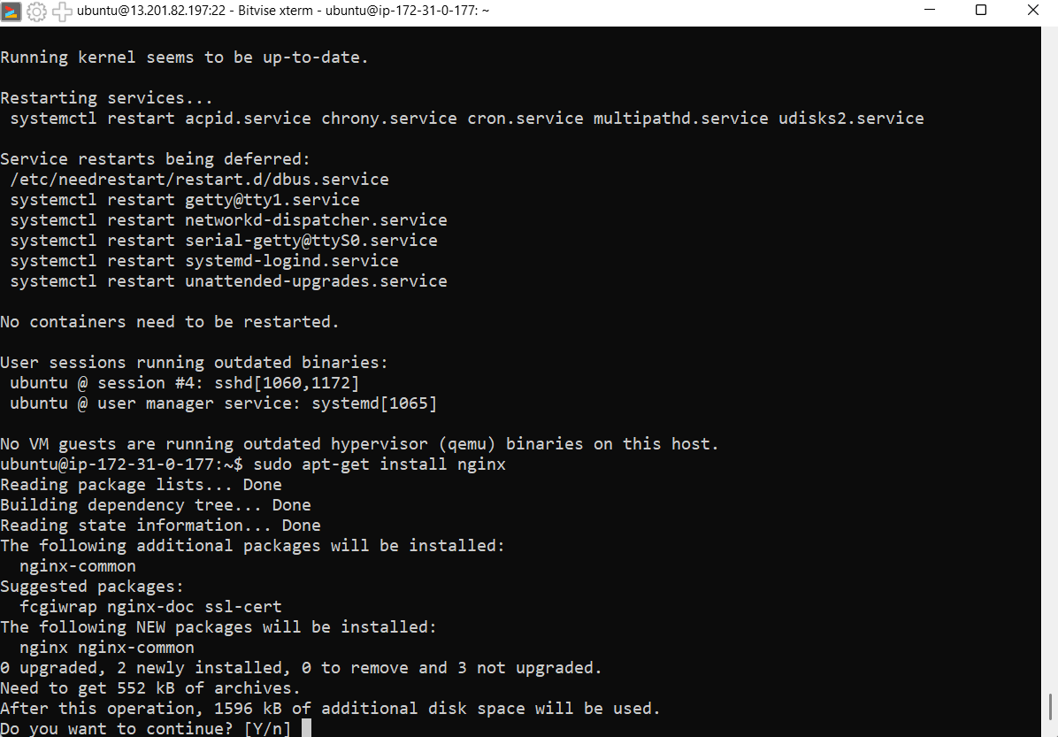

**(After performing the above step press: Y then press Enter).**

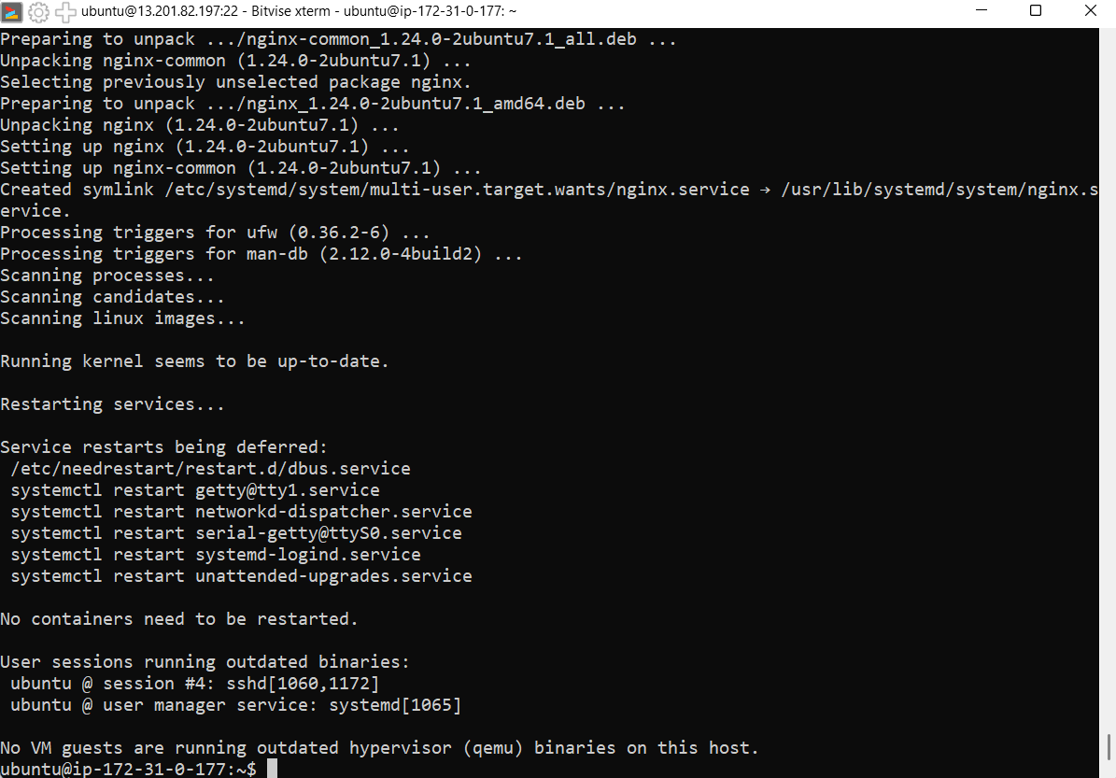

1. Verify the installation:

nginx -v

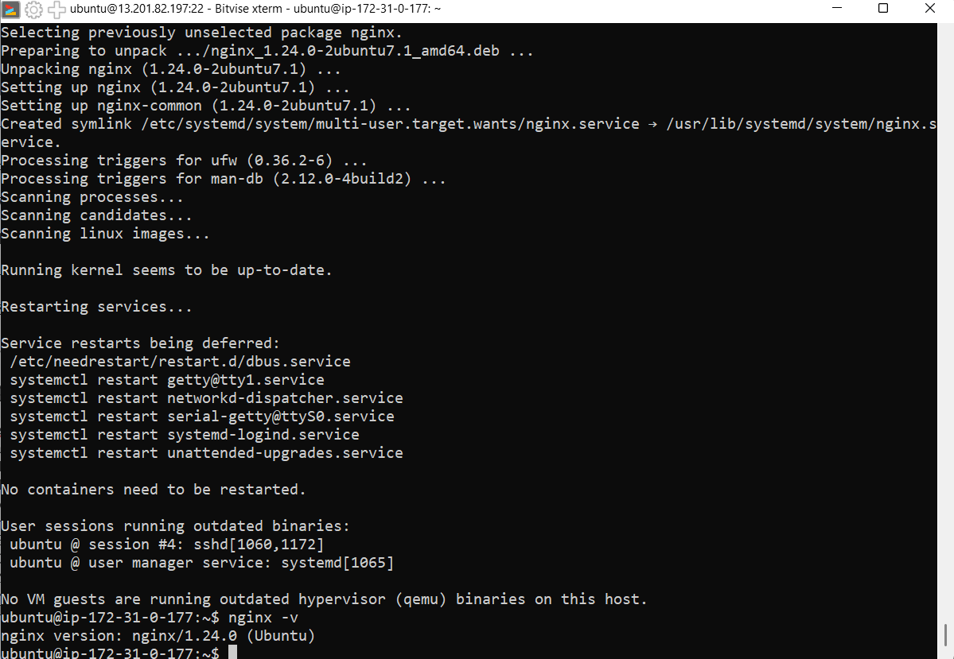o You should see an output like nginx version: nginx/1.18.0 (Ubuntu).

**(Showing Output as: nginx version: nginx/1.24.0 (Ubuntu)).**

# Step 4: Upload Website Files

1. In **Bitvise SSH Client**, open a **New SFTP Window**.

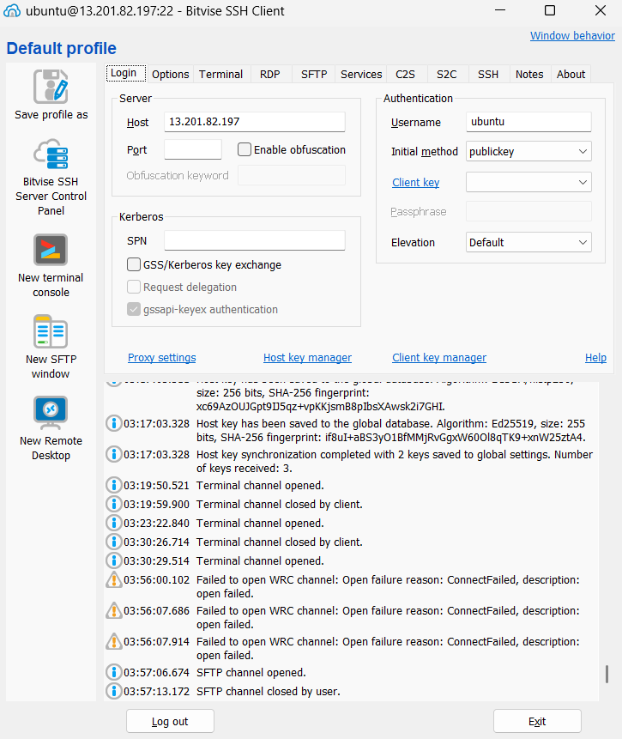

**(Click on “New SFTP Window”).**

1. The window has two sections:
   * **Local Files** (Your computer)
   * **Remote Files** (EC2 instance)

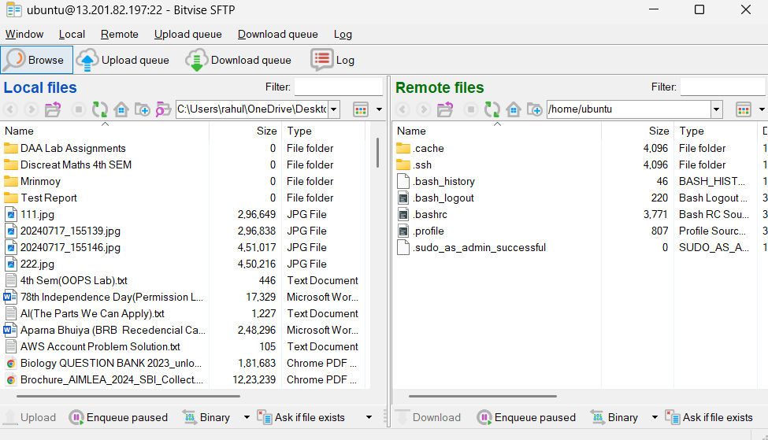

**(New SFTP Window).**

1. Navigate to your local folder containing the static website files (index.html,

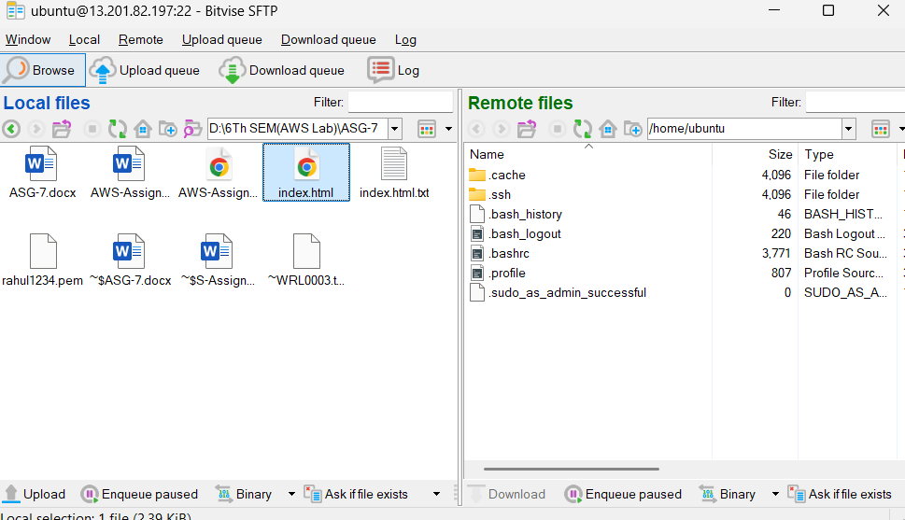about.html, next.html).

1. On the **Remote Files** side, follow these steps:
   * Click the folder icon **until you reach the root directory (/)**.
   * Navigate to:
   * 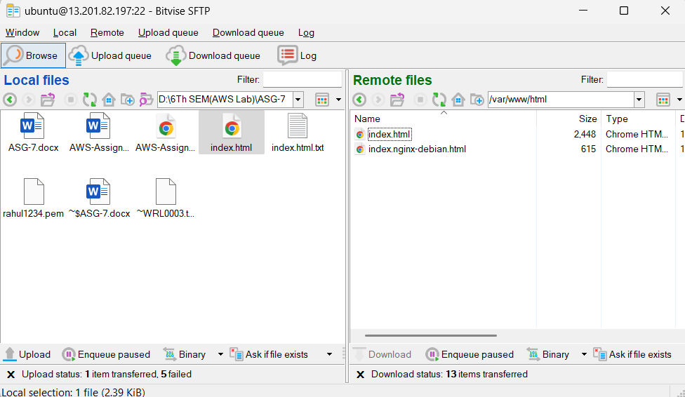/var/www/html

**(Type: “/var/www/html” on the Remote files).**

1. **Adjust File Permissions** (If needed):

sudo chmod 777 /var/www/html

* + This allows file uploads.

1. **Drag and Drop the Files** (index.html, about.html, next.html) from **Local Files**

to **Remote Files** inside /var/www/html.



**Remark**: If permission errors occur, re-run the chmod command and try uploading again.

# Step 5: Access the Website

1. Open a web browser.
2. Paste the **Public IPv4 Address** in the address bar.
3. Press **Enter**.
4. If configured correctly, your **index.html** page should load, confirming the website is live.

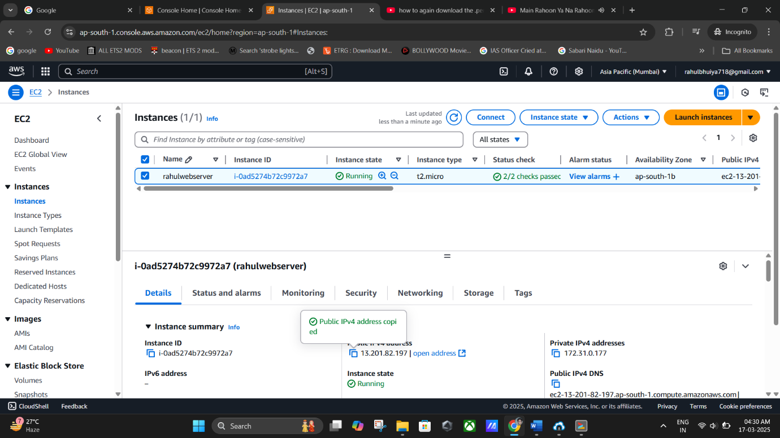

**(Copying the “Public IPv4 Address” from the AWS instances console).**

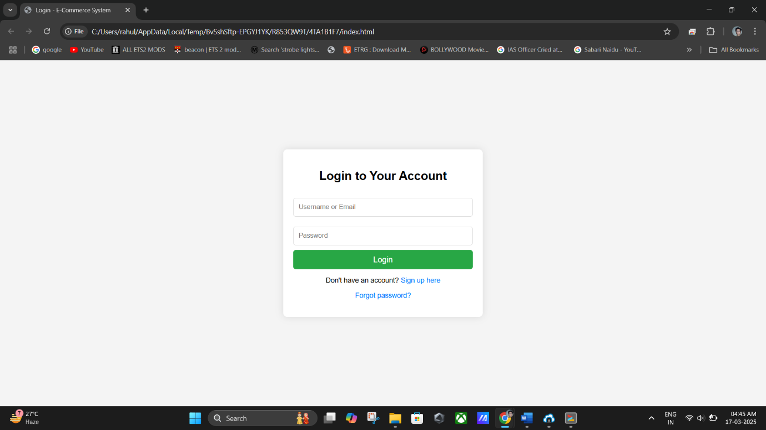

**(Finally Webpage is Working).**

# Final Notes

* + If the website does not load, ensure:
    - The **NGINX server** is installed and running (sudo systemctl status nginx).
    - The **firewall settings** allow HTTP and HTTPS traffic.
    - The **file permissions** are correctly set for /var/www/html.
  + The **bucket name must be unique** across AWS.
  + For enhanced security, use **IAM roles and access policies** to restrict access.